

**Data Technician**

|  |
| --- |
|  |

|  |
| --- |
| Name: Michael Thirlaway |
| Course Date: 11/08/2025 |
|  |

**Table of contents**

Day 1: Task 1 3

Day 1: Task 2 4

Day 1: Task 3 5

Day 1: Task 4 6

Day 2: Task 1 7

Day 3: Task 1 11

Day 3: Task 2 12

Day 3: Task 3 14

Day 4: Task 1 15

Day 4: Task 2 16

Day 4: Task 2 (Optional) 17

**1. Scenario Background** 17

**2. Data Laws and Regulations** 17

**3. Azure Service Recommendations** 17

**4. Data Types and Data Modelling** 17

**5. Data Storage Formats and Structures in Azure** 18

**6. Additional Considerations** 18

**Submission Guidelines:** 18

**Course Notes** 21

**Additional Information** 22

# Day 1: Task 1

Please research and complete the below questions relating to key concepts of cloud.

Be prepared to discuss the below in the group following this task.

|  |  |
| --- | --- |
| What can cloud computing do for us in the real-world? | Cloud computing allows us to store, manage, and process data over the internet instead of relying on local computers or servers which are more costly to set up and maintain. In the real world, this can be seen with services like Google Drive or Microsoft 365, where we can keep documents and other files without using our own internal storage. |
| How can it benefit a business? | This benefits a business because it reduces the need for expensive in-house servers and all the associated costs of maintaining that infrastructure like staff and security, etc. It offers scalability (as well as easily increasing or decreasing resources based on demand. Shared data can be accessed remotely and comes with built-in security and backups. Businesses can also access powerful analytics and AI tools without large upfront investment. |
| What’s the alternative to cloud computing? | The main alternative is on-premises computing, where a company would own and manage its own physical servers, storage, and networking infrastructure in-house or in a data center. This would give them more control but it far more expensive up front. |
| What cloud providers can we use, what are their features and functions? | There are many cloud providers such as:  Amazon Web Services, which offers storage, computing, databases, and AI.  Microsoft Azure – This has a strong integration with Microsoft products. Also offers virtual machines, databases, AI, and enterprise services.  Google Cloud Platform – Data analytics, machine learning, and scalable computing.  IBM Cloud – Hybrid cloud, AI with Watson, and security.  Oracle Cloud – Databases and enterprise applications. |

# Day 1: Task 2

Please research the below cloud offerings, explain what they are and examples of use cases.

|  |  |  |
| --- | --- | --- |
| Cloud Offerings | Explain what it is | When / how might you use this service in the real-world? |
| IaaS (Infrastructure as a service) | Provides virtualised computing resources over the internet such as servers, storage, and networking on a pay as you go basis. | If you want to host a website, run custom applications, or store large amounts of data without buying physical hardware. For example, Microsoft Azure’s virtual machines can be used to run an e-commerce website. |
| PaaS (Platform as a service) | A cloud environment for developing, running, and managing applications without handling the underlying infrastructure. This includes tools, frameworks, and databases. | When building a custom app and you want to focus on coding rather than server setup. For example, using Google App Engine to develop and deploy a booking system. |
| SaaS (Software as a service) | Ready to use software delivered via the internet, accessible through a browser or app, with hosting and maintenance handled by the provider. | For everyday business tasks like email, file storage, or customer relationship management. For example, using Microsoft 365 for document editing and collaboration. |

# Day 1: Task 3

Pricing Calculator: **In this exercise, you use the Pricing calculator to estimate the cost of running a basic web application on Azure.**

|  |  |
| --- | --- |
| Cost of a basic web application | In the price calculator, to run a basic web application, I added the app service, storage accounts, and the Azure SQL Database. The estimated monthly cost is $1554.13. |

TCO Calculator: **In this exercise, you use the Total Cost of Ownership (TCO) Calculator to compare the cost of running a sample workload in your datacentre versus on Azure.**

|  |  |
| --- | --- |
| Datacentre vs Azure | Completed |

# Day 1: Task 4

Please research the below terms and explain what they are, when they would be appropriate and a real-world example of where it could be implemented (i.e. what type of organisation).

|  |  |
| --- | --- |
| Public Cloud | Cloud services offered over the internet by third-party providers, shared between multiple users. They would be appropriate when cost savings and scalability are priorities, and sensitive data control is not a strict requirement. For example, a small business using Microsoft Azure or AWS to host a website. |
| Private Cloud | Cloud infrastructure dedicated to a single organisation, either hosted on-site or by a provider. A private cloud would be needed when security, compliance, or customisation is critical. For example, a government agency running a private cloud for classified data processing. |
| Hybrid Cloud | Hybrid cloud combines public and private systems, allowing data and applications to move between them. This works well when a company wants to keep sensitive workloads private but still take advantage of the public cloud for less critical tasks. For example, a bank might store customer data privately but use the public cloud for its mobile banking app. |
| Community Cloud | A community cloud is shared between organisations with similar goals or compliance needs. It’s useful when groups need to collaborate securely, such as several universities sharing a cloud system to store and analyse research data. |

# Day 2: Task 1

Describe, with examples, the **three** major areas that the Computer Misuse Act deals with.

|  |  |  |
| --- | --- | --- |
| Area | Description | Example |
| Unauthorized access to computer material | Gaining access to a computer, network, or data without permission. | Hacking into someone’s email account without their consent. |
| Unauthorized access with intent to commit further offences | Accessing a system without permission in order to commit another crime, such as fraud or theft. | Breaking into a company’s database to steal customer credit card details for financial gain. |
| Unauthorised modification of data | Changing, deleting, or adding data without permission, including spreading malware or other viruses. | Creating and distributing a virus that corrupts files on people’s computers. |

The computer misuse act 1990 is an act where an individual can be criminalised because of computer related offense. Describe three extra powers that the Police and Justice Act 2006 (Computer Misuse) has added.

|  |
| --- |
| Description |
| Making DoS attacks illegal (Denial of Service). This makes it an offence to impair the operation of a computer, including DoS or DDoS attacks that flood computers with traffic. |
| Criminalising the supply of hacking tools. It is now illegal to create, supply, or obtain tools, software, or data intended to be used for committing computer misuse offences. |
| Increased penalties for offences. The act raised maximum prison sentences from 5 years to up to 10 years for serious cases, allowing harsher punishments for serious cyber crimes. |

Look at the below website to answer the questions:

<https://www.gov.uk/personal-data-my-employer-can-keep-about-me>

|  |
| --- |
| Write down three items of data which a company can store about an employee. |
| Full name |
| Home address |
| National Insurance Number |

|  |
| --- |
| Give three more examples of data that an employer can only store if they first get the employee’s permission. |
| Medical records |
| Biometric data such as finger prints or facial recognition |
| Religious beliefs |

Conduct further research to answer the below questions.

|  |  |
| --- | --- |
| Question | Answer |
| Provide one example of: Copyright infringement | Downloading and sharing a movie from a torrent site without the copyright holder’s permission. |
| Provide one example of: Plagiarism | |  | | --- | |  |  |  | | --- | | Copying text from an online article into an essay without citing the source. | |
| What are two consequences of copyright infringement and software piracy? | Legal action and fines.  Loss of revenue for creators and businesses. |
| Give three possible consequences for individuals when using pirated software | Exposure to malware and viruses.  Lack of access to software updates and support.  Risk of legal penalties or prosecution. |

Listed below are some laws which we have covered today:

1. Computer Misuse Act 1990

2. Police and Justice Act 2006 (Computer Misuse)

3. Copyright, Designs and Patents Act 1988

4. Copyright (Computer Programs) Regulations 1992

5. The Health and Safety (Display Screen Equipment) Regulations 1992

6. Data Protection Act 2018

7. Consumer Rights Act 2015

* Insert a number in the first column of each row to match each of the statements with one of the above Acts.
* One of statements is incorrect and not illegal. For this statement, write ‘Not illegal’.

|  |  |
| --- | --- |
| **Act number** | **Clause** |
| 4 | With some exceptions, it is illegal to use unlicensed software |
| 7 | Any product, digital or otherwise, must be fit for the purpose it is supplied for |
| 2 | Unauthorised modification of computer material is illegal |
| Not illegal | It is illegal to create or use a hacking tool for penetration testing |
| 6 | Personal data may only be used for specified, explicit purposes |
| 5 | Employers must provide their computer users with adequate health and safety training for any workstation they work at |
| 2 | It is illegal to distribute hacking tools for criminal purposes |
| 3 | It is illegal to distribute an illicit recording |
| 6 | Personal data may not be kept longer than necessary |
| 1 | Gaining unauthorised access to a computer system is illegal |
| 5 | Employers must ensure that employees take regular and adequate breaks from looking at their screens |
| 2 | It is illegal to prevent or hinder access (e.g. by a denial-of-service attack) to any program or data held in any computer |
| 6 | Personal data must be accurate and where necessary kept up to date |

# Day 3: Task 1

Please complete the below lab (3) *‘Explore relational data in Azure’* and paste evidence of the completed lab in the box provided.

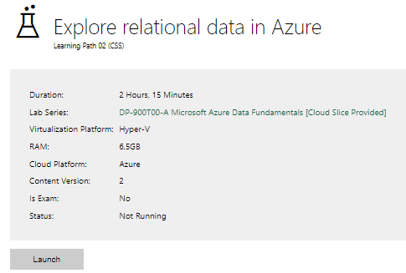

|  |  |
| --- | --- |
| Completed lab |  |

# Day 3: Task 2: Skillable

Complete below exercises in lab environment using AdventureWorks DB.

**-- 1. Customers with last names starting with 'A'**

-- Scenario: The marketing department is preparing a campaign targeting customers whose last names begin with the letter 'A'. They need a list of these customers to personalize outreach messages.

**-- 2. Customers with first name starting with 'A' and last name ending with 'a'**

-- Scenario: The CRM team is analyzing customer name patterns for personalization strategies. They're particularly interested in users with a first name starting with 'A' and a last name ending in 'a'.

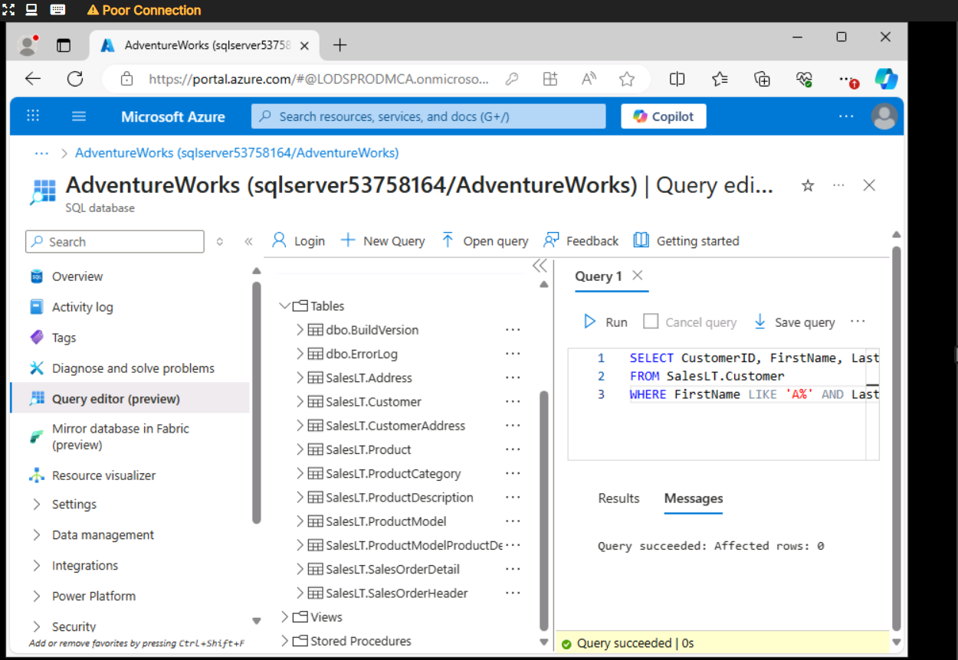

**-- 3. Count of customers with first name starting with 'A' and last name including 'o'**

-- Scenario: A data analyst is generating statistics for a name segmentation report and needs to count how many customers meet both criteria: first name starts with 'A' and last name contains the letter 'o'.

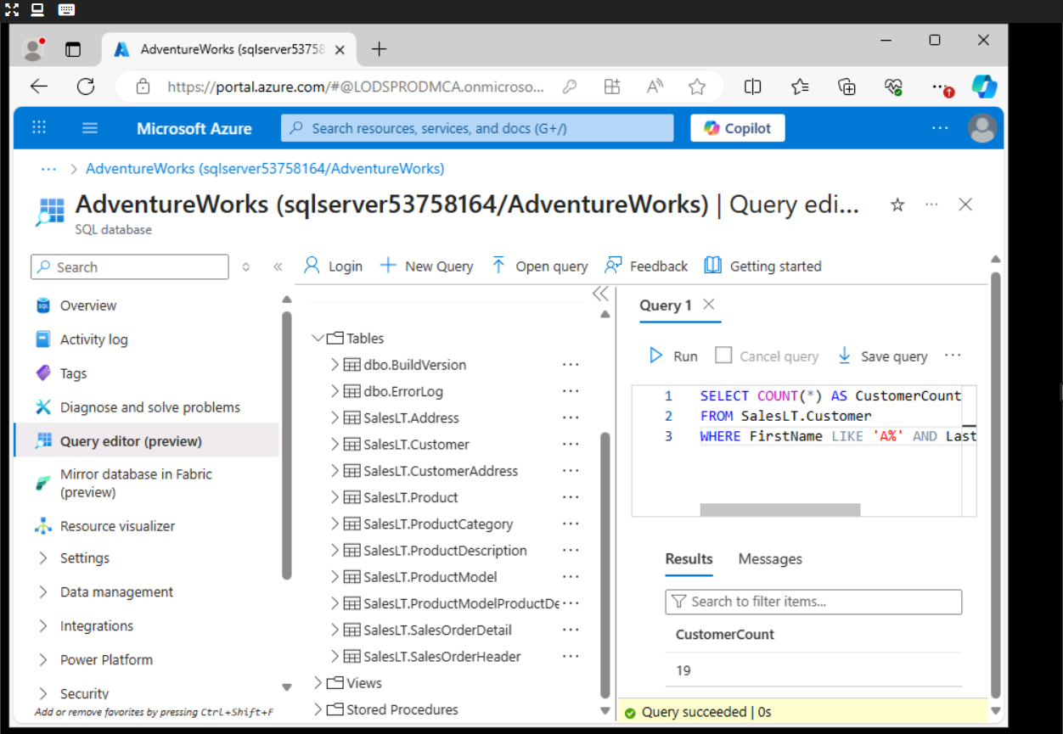

**-- 4. Top 3 black products of size 'S' ordered by list price**

-- Scenario: The merchandising team is curating a list of 'Black' colored products in size 'S' for a limited-time promotion. They want to showcase the top 3 most affordable options first.

**-- 5. Average standard cost of products**

-- Scenario: The finance team is calculating the average standard cost across all products to assess baseline production expenses.

**-- 6. Difference between average standard cost and average list price**

-- Scenario: The pricing strategy team is examining the average markup between the standard cost and the list price to evaluate profitability trends.

**-- 7. Product with highest profit margin**

-- Scenario: Management wants to identify the most profitable product by finding the item with the highest difference between list price and standard cost.

**-- 8. Number of products per category**

-- Scenario: Inventory control needs a summary of how many products exist in each product category to manage stock levels effectively.

**-- 9. Average list price by category**

-- Scenario: The product pricing team is reviewing average list prices by category to adjust pricing strategies and identify outliers.

**-- 10. Orders with customer information**

-- Scenario: The operations team needs a comprehensive report of customer orders, including order details and basic customer info, to review sales performance.

**-- 11. Products priced above average list price**

-- Scenario: The sales team wants to identify premium products that are priced above the average list price for highlighting in high-end marketing campaigns.

**-- 12. Total quantity sold per product**

-- Scenario: The business intelligence team is evaluating product performance by analyzing the total quantity sold for each product across all orders.

**-- 13. Total sales per customer**

-- Scenario: The customer success team wants to calculate the total value of orders placed by each customer to identify high-value clients for loyalty programs.

# Day 3: Task 3: Skillable

Please complete the below lab (4) *‘Explore non-relational data in Azure’* and paste evidence of the completed lab in the box provided.

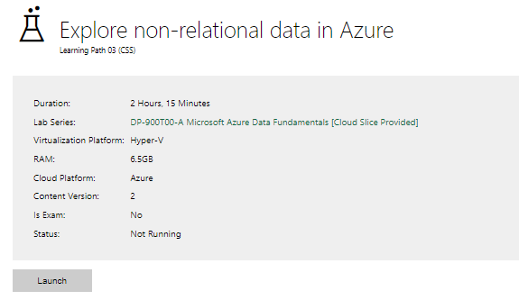

|  |  |
| --- | --- |
| Completed lab |  |

# Day 4: Task 1: MS Fabric using Just IT

Please follow the link below to complete the lab using your Just IT account in MS Fabric.

There are 3 modules to complete.

[Data Factory end-to-end tutorial introduction and architecture - Microsoft Fabric | Microsoft Learn](https://learn.microsoft.com/en-us/fabric/data-factory/tutorial-end-to-end-introduction)

# Day 4: Task 2: Skillable

In your teams, complete the Azure DP-900 practice exam and paste your result below – this is open book and please research and discuss your answers as a team.

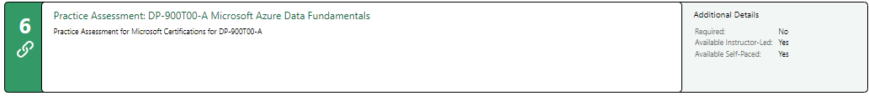

|  |  |
| --- | --- |
| Result |  |

# Day 4: Task 2 (Optional)

#### **1. Scenario Background**

"Paws & Whiskers" is a growing pet shop that aims to improve its business by analysing sales, customer information, and inventory data. Currently, the data is collected manually or stored in spreadsheets. Management is interested in transitioning to Microsoft Azure to streamline data storage, analysis, and reporting, enabling them to make data-driven decisions.

#### **2. Data Laws and Regulations**

Identify and explain the data laws and regulations relevant to handling customer data within the proposal. Ensure you cover the following points:

* **GDPR Compliance**: Highlight the importance of adhering to the General Data Protection Regulation (GDPR), particularly as it relates to storing and processing customer information.
* **Data Protection Act (DPA) 2018**: Outline how the DPA 2018 may affect the way "Paws & Whiskers" collects and stores data, ensuring compliance with UK laws on data privacy.
* **Other Industry Standards**: Research any additional data protection standards or regulations that may apply to pet shop data, particularly if they involve sensitive or payment information.

#### **3. Azure Service Recommendations**

Recommend Microsoft Azure services that would suit the company’s data analysis needs and explain why these services are suitable. Your recommendations should include:

* **Data Storage**: Identify suitable storage options, such as **Azure Blob Storage** or **Azure SQL Database**, and discuss the benefits of each for storing large datasets, including inventory, sales transactions, and customer details.
* **Data Analysis Tools**: Recommend tools such as **Azure Machine Learning** for customer behaviour analysis or **Azure Synapse Analytics** for analysing sales trends.
* **Data Integration and Automation**: Explain how services like **Azure Data Factory** could automate data collection and integration processes, improving efficiency.

#### **4. Data Types and Data Modelling**

Define the types of data "Paws & Whiskers" will need to work with and describe your approach to data modelling:

* **Data Categories**: Identify key data types, such as customer demographics, transaction history, pet inventory, and product categories.
* **Data Modelling Approach**: Outline how you would structure this data using a relational model or a data warehouse approach, considering factors like tables, entities, relationships, and primary keys.

#### **5. Data Storage Formats and Structures in Azure**

Discuss how you would store data within Azure and the formats you would recommend:

* **Data Formats**: Specify recommended formats (e.g., CSV for raw data imports, JSON for structured data, Parquet for analytics) and explain why these formats are suitable for specific data types.
* **Data Security and Encryption**: Include recommendations for securing data using Azure’s built-in encryption features and access controls to ensure compliance with data privacy regulations.

#### **6. Additional Considerations**

Provide any other considerations that might enhance data handling and efficiency in Azure, such as:

* **Backup and Disaster Recovery**: Outline a backup plan using **Azure Backup** or **Azure Site Recovery** to safeguard against data loss.
* **Data Visualisation**: Discuss potential use of **Power BI** within Azure for creating dashboards that provide management with real-time insights into sales and customer trends.
* **Future Scalability**: Comment on how Azure services can scale as the business grows, accommodating larger datasets and more complex analyses.

### **Submission Guidelines:**

1. **Structure**: Ensure your report is well-organised, with sections for each task (e.g., Data Laws, Azure Services, Data Types, etc.).
2. **Formatting**: Include headings, bullet points where appropriate, and any visuals or diagrams that support your explanations.
3. **References**: Cite any resources or regulations referenced in the report.
4. **Length**: Aim for 1500-2000 words.

|  |
| --- |
|  |

|  |
| --- |
| **Course Notes** |

It is recommended to take notes from the course, use the space below to do so, or use the revision guide shared with the class:

|  |
| --- |
| **Additional Information** |

We have included a range of additional links to further resources and information that you may find useful, these can be found within your revision guide.

**END OF WORKBOOK**

**Please check through your work thoroughly before submitting and update the table of contents if required.**

**Please send your completed work booklet to your trainer.**